READ ME
🌿 Herbal Plants Website

A simple and responsive website built using HTML5 and CSS3 to spread awareness about India's most popular medicinal plants and their health benefits.

This is my first front-end web development project, created to improve my HTML and CSS skills while building something useful and informative.

---

📸 Preview

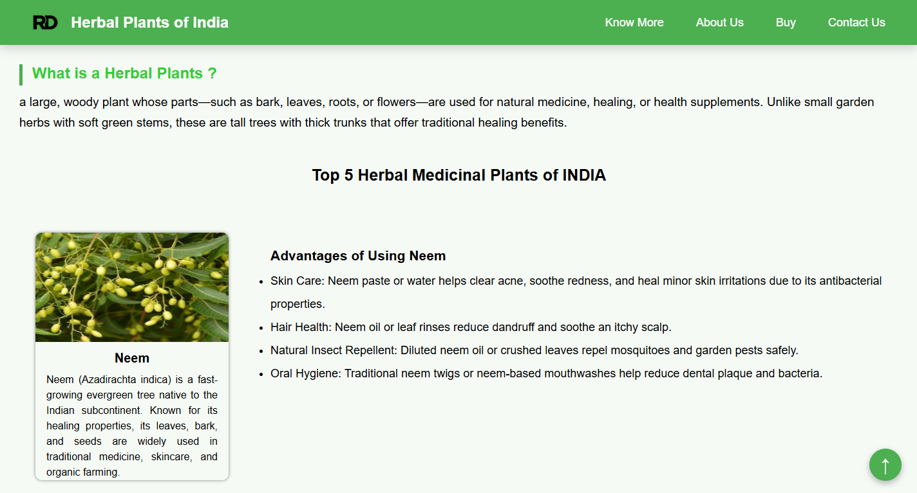

🌱 About the Project

This website introduces some of the most commonly used medicinal plants in India, including:

- Neem
- Tulsi
- Ashwagandha
- Turmeric
- Brahmi

Each section contains:
- A short introduction
- Health benefits
- Simple and clean design
- Easy navigation

The website also explains why medicinal plants are important for our health and the environment.

---

✨ Features

- Responsive design for desktop and mobile devices
- Sticky navigation bar
- Smooth scrolling
- Hover animations
- Modern card layout
- Back to Top button
- Clean footer with social links
- External links for additional information

🛠️ Technologies Used

- HTML5
- CSS3
- Flexbox
- Media Queries

---

📁 Project Structure

Herbal-Plants/
│
├── index.html
├── style.css
├── logo.png
├── neem.png
├── tulsi.png
├── ashwagandha.png
├── turmeric.png
├── brahmi.png
└── README.md

---

🚀 How to Run

1. Download or clone this repository.

```
git clone https://github.com/Rahul1714M/Herbla_Plants.git
```

2. Open the project folder.

3. Double-click index.html or open it in your browser.

No installation or additional software is required.

---

🎯 What I Learned

While building this project, I practiced:

- HTML page structure
- CSS styling
- Flexbox
- Responsive web design
- Hover effects
- Smooth scrolling
- Creating reusable layouts
- Organizing a project properly

💡 Future Improvements

I plan to add:

- JavaScript for more interactivity
- Search feature
- Dark mode
- More medicinal plants
- Better animations
- Improved mobile navigation

---

👨‍💻 About Me

Hi, I'm Rahul Das.

I'm a BCA student who enjoys learning web development and programming. I created this project to improve my front-end development skills and to build my portfolio.

I am currently learning:

- HTML
- CSS
- JavaScript
- C
- C++
- Java

---

📬 Connect with Me

GitHub
https://github.com/Rahul1714M

LinkedIn
https://www.linkedin.com/in/rahul-das-a398622b9/

Email
rd7478521@gmail.com

---

⭐ Support

If you like this project, please consider giving it a ⭐ on GitHub.

Thank you for visiting my repository!

